SIMATS ENGINEERING (SAVEETHA SCHOOL OF ENGINEERING)
Department of Computer Science and Engineering
ASSESSMENT TOOL 2 – Scenario-Based

Course Code: | ITA0532 | Course Title: | Computer Vision
CO Assessed: | CO2 – Imitation (BL3) | Assessment: | Assessment Tool 1 – Scenario-Based
Weightage: | 10% of CIA | Total Marks: | 100
CO2 Statement: | Apply image enhancement and segmentation techniques for extracting meaningful regions from images. (BTL 3)
Student Name: | KARTHIGA | Reg. No.: | 192421383
Section / Batch: | 2024/B | Date: | 05 08 2026

Code of Conduct
I __________ KARTHIGA ________________ (Name / Reg No) certify that this submission is my original work and that I have adhered to the guidelines specified for this assessment. I understand that any violation of academic integrity rules will result in disciplinary action.
Signature of the Student: ____ KARTHIGA _____________________

RUBRICS FOR CALCULATION: ASSESSMENT TOOL 2: Scenario-Based

Criteria | Weightage | Level 4 – Exemplary | Level 3 – Proficient | Level 2 – Developing | Level 1 – Beginning | Marks
Understanding of Scenario | 20% | Demonstrates clear and complete understanding of the scenario and context | Shows good understanding with minor gaps | Partial understanding; misses key aspects | Misinterprets or fails to understand the scenario
Identification of Key Issues | 20% | Accurately identifies all relevant issues and factors involved | Identifies most key issues with minor omissions | Identifies limited issues; some irrelevant points | Unable to identify key issues
Application of Concepts | 25% | Applies appropriate concepts effectively to address the scenario | Applies concepts with minor errors | Limited or partially correct application | Unable to apply relevant concepts
Decision Making | 20% | Makes well-reasoned, logical decisions with strong rationale | Makes reasonable decisions with some justification | Makes weak decisions with limited justification | No clear decisions made or rationale provided
Clarity of Response | 15% | Response is clear, structured, and logically presented | Generally clear with minor issues | Somewhat unclear or poorly structured | Disorganized and difficult to understand

QUESTION 9 – BROKEN EDGES
(a) Interpretation of the Scenario – Understanding of Scenario (20%)
After applying an edge detection technique to an image, the boundaries of objects appear discontinuous or broken. This indicates that the edge detector has detected only some portions of the object boundary while missing other portions.
Edge detection methods such as Canny Edge Detection identify boundaries by detecting significant changes in pixel intensity. When the image contains noise, low contrast, weak intensity changes, or uneven illumination, some boundary pixels may not be detected. This results in gaps or discontinuities in the detected edges.
The objective is therefore to improve the connectivity of the detected edges and obtain a more continuous and meaningful object boundary.

(b) Key Issues Affecting Boundary Continuity – Identification of Key Issues (20%)
The important factors responsible for broken object boundaries are:
- Image Noise: Random variations in pixel intensity can disturb the actual boundary.
- Low Contrast: When the object and background have similar intensity values, the boundary becomes difficult to detect.
- Threshold Selection: An unsuitable threshold may remove weak but important edge pixels.
- Uneven Illumination: Changes in lighting can make some portions of the boundary stronger or weaker.
- Weak Intensity Gradient: A gradual change between the object and background may not produce a strong edge.
- Object Texture: Texture can create additional unwanted edges and interfere with the actual boundary.
- Small Gaps: Missing edge pixels can cause discontinuity between two nearby edge segments.
These factors reduce the continuity and accuracy of the detected object boundary.

(c) Suitable Method to Improve Edge Connectivity – Application of Concepts (25%)
To address the broken-edge problem, Gaussian Blur, Canny Edge Detection, and Morphological Closing are applied.
Method
Input Image → Grayscale Conversion → Gaussian Blur → Canny Edge Detection → Morphological Closing → Connected Edges
1. Gaussian Blur
Gaussian Blur is first applied to reduce noise in the image. This helps prevent unwanted pixels from being detected as edges.
2. Canny Edge Detection
Canny Edge Detection is then applied to identify the important boundaries of the object.
3. Morphological Closing
Morphological closing is applied to the detected edges using a small 3 × 3 kernel.
Morphological closing consists of:
Dilation → Erosion
- Dilation expands edge pixels and connects nearby broken edge segments.
- Erosion removes unnecessary expansion while preserving the connected boundary.
Python Program
import cv2
import numpy as np
import matplotlib.pyplot as plt

# Read the input image
image = cv2.imread("sample.jpg")

# Check whether image is loaded
if image is None:
print("Error: sample.jpg not found")
print("Keep sample.jpg in the same folder as this Python file.")
exit()

# Convert image to grayscale
gray = cv2.cvtColor(image, cv2.COLOR_BGR2GRAY)

# Reduce noise
blur = cv2.GaussianBlur(gray, (5, 5), 0)

# Detect edges using Canny
edges = cv2.Canny(blur, 50, 150)

# Create a 3 x 3 kernel
kernel = np.ones((3, 3), np.uint8)

# Apply morphological closing
connected_edges = cv2.morphologyEx(
edges,
cv2.MORPH_CLOSE,
kernel
)

# Display the results
plt.figure(figsize=(12, 4))

plt.subplot(1, 3, 1)
plt.imshow(cv2.cvtColor(image, cv2.COLOR_BGR2RGB))
plt.title("Original Image")
plt.axis("off")

plt.subplot(1, 3, 2)
plt.imshow(edges, cmap="gray")
plt.title("Broken Edges")
plt.axis("off")

plt.subplot(1, 3, 3)
plt.imshow(connected_edges, cmap="gray")
plt.title("Connected Edges")
plt.axis("off")

plt.tight_layout()
plt.show()
Expected Output
The output contains three stages:
Original Image → Broken Edges → Connected Edges
The second image shows the edges detected by Canny, where some boundaries may be discontinuous. After morphological closing, nearby broken edge segments are connected and small gaps are filled.
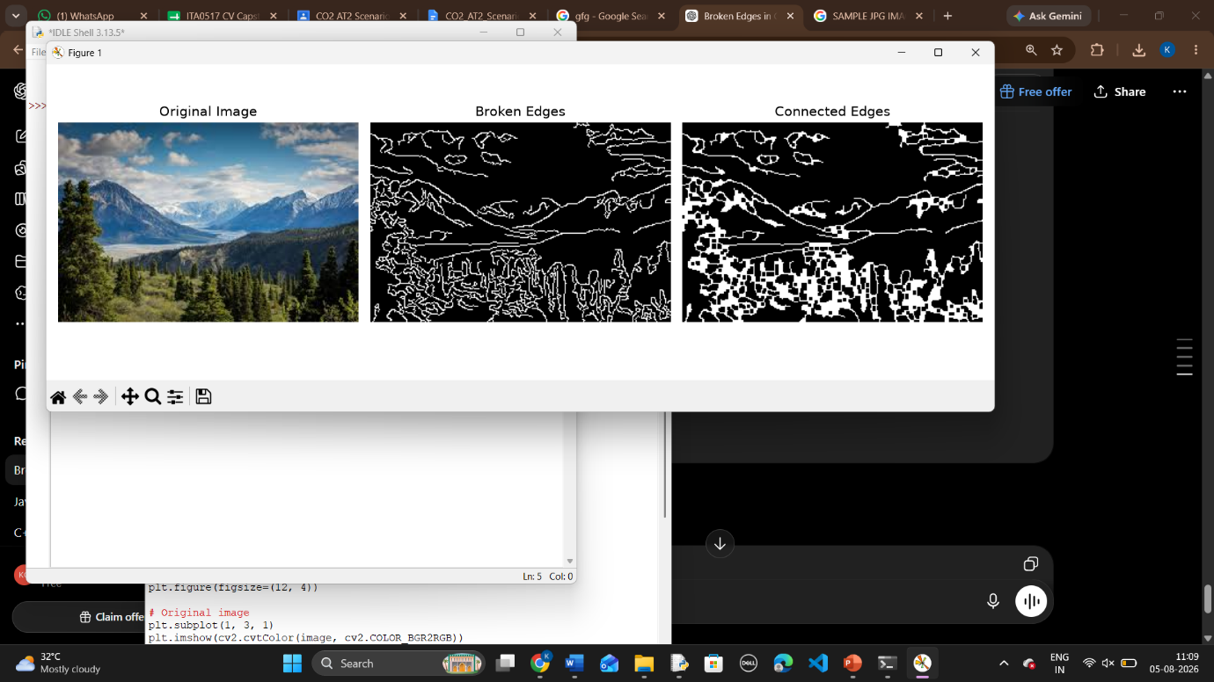

(d) Justification of the Approach – Decision Making (20%)
Morphological closing is selected because the specific problem is broken or discontinuous object boundaries.
The decision is logically justified as follows:
- Gaussian Blur reduces noise before edge detection.
- Canny detects the significant boundaries of the object.
- Dilation connects nearby edge pixels and fills small gaps.
- Erosion removes excessive pixels introduced by dilation.
- A 3 × 3 kernel is suitable for connecting small gaps while maintaining the general shape of the boundary.
Therefore, the combination of Gaussian Blur + Canny Edge Detection + Morphological Closing directly addresses the identified causes of broken edges and produces a more continuous boundary.

(e) Clear Explanation – Clarity of Response (15%)
The broken-edge problem occurs because some portions of an object's boundary are not detected correctly. Noise, low contrast, unsuitable thresholding, uneven illumination, weak gradients, object texture, and missing edge pixels can cause discontinuities.
To solve the problem, Gaussian Blur is first used to reduce noise. Canny Edge Detection is then used to detect the object boundary. Finally, morphological closing with a 3 × 3 kernel is applied to connect nearby broken edges.
The dilation operation connects the edge segments, while erosion removes unnecessary expansion. As a result, the detected boundary becomes more continuous and suitable for further image processing tasks such as segmentation and object extraction.
Final Conclusion
The proposed method effectively improves edge connectivity by combining noise reduction, edge detection, and morphological processing. It provides a logical and appropriate solution to the broken-edge scenario and produces more continuous object boundaries.

